Звіт з бд

лр 2

Гніздовський Максим

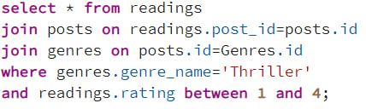

/*мої власноруч написані запити*/

/*1*/Select * from human

Where role = "Superviser";

/*2*/Select id,role,date_of_birth from human;

/*3*/select * from human group by human_id having(id<200);

/*4*/select count(role) from human;

/*5*/select avg(rating_post) from posts where created _at > '2000-01-01';

/*6*/select max(rating_post) from posts;

/*7*/select distinct role from human;

/*8*/insert into posts(title) values('Habr article about principles of SOLID');

/*9*/alter table Genres add column additional_genres varchar;

/*10*/select * from readers;

/*11*/select * from readers where not readed_at isnull;

/*12*/update posts title='SOLID habr' where title = 'Habr article about principles of SOLID';

/*13*/select coalesce(rating_post, created_at) as coalesce_row from posts;

/*14*/select * from genres where Genre_name%g 'Thriller';

/*15*/SELECT created_at

FROM posts;

WHERE created_at BETWEEN '1985-10-05' AND '2007-10-10';

/*16*/select * from posts where rating_post like '3$';

/*17*/select * from posts where rating_post like '2$'

/*18*/select * from posts where rating_post like '1$'

/*19*/select rating_post from posts where rating_post<5 and rating_post>3

/*20*/select rating_post from posts join genres;

/*21*/select rating_post from posts and Genre_name from genres group by Genre_name;

/*22*/select rating_post from posts and Genre_name from genres order by pating post desc;

/*23*/select * from posts group by id having count(id)>5;